Large Abdominal Aortic Aneurysm with Colon Cancer
Stem: A 68 year-old-male is worked up by his PCP for lower GI bleeding and found on colonoscopy to have a mass in the sigmoid colon.
Biopsy showed a T3 adenocarcinoma.
For staging, CT of the chest abdomen and pelvis reveals a 2cm sigmoid mass, no evidence of metastatic disease, and a 6.5 cm infrarenal AAA.
Plus this image.
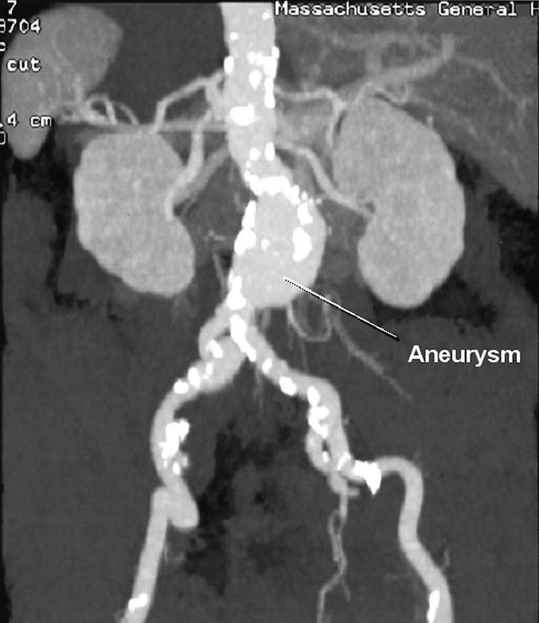
He is referred to your office for management. His medical history is significant for a 50 pack-year smoking history, diet-controlled diabetes, and hypertension on lisinopril.
He is vitally normal, and asymptomatic at this time aside from his lower GI bleed. His hemoglobin last week was 7.2.
Any additional Workup or Studies:

- CTA to evaluate AAA anatomy:
S hows 1.7cm infrarenal neck, 2cm neck diameter, 40° neck angle, 1cm femoral artery diameter.

What Would you like to do Now?
- EVAR candidate
- Pre-op optimization
  - S moking cessation
  - D iabetes and BP control.
  - Monitor anemia optimize with iron and vitamin supplements.
  - Pre-op type and screen
- EVAR first, followed by left hemicolectomy in 2 weeks.

What is the risk of aneurysm rupture after laparotomy for non-vascular cause?

Increasedmay be due to activation of matrix metalloproteinases. Thus, aneurysm should be addressed.

Scenario : The patient is taken to the OR for EVAR, and on post op CT scan 1 week later demonstrates an asymptomatic type 2 endoleak from the IMA. How would you like to proceed?
- Proceed withcolectomy
- H igh ligation of the IMA which will resolve the endoleak.

Scenario: A similar patient presents to the ED with abdominal pain and is found to have an obstructing sigmoid mass and a concurrent 5.5 cm AAA. How would you proceed in this case?
- Urgent colectomy for resection of the mass and relief of the obstruction. Strongly consider colostomy or diverting loop ileostomy
- Interval AAA repair either open retroperitoneal or EVAR approach

This patient will need adjuvant chemotherapy, when should he get it?
A fter AAA repair to minimize risk of AAA rupture

Scenario: The same patient, with an obstructing sigmoid mass but now an 8cm AAA.
- Both the obstruction and the AAA should be dealt with urgently.
- Consider stenting the obstruction as a bridge to colectomy
- AAA repair during this hospitalization
- CT chest abdomen and pelvis during this hospitalization for metastatic workup for colon cancer

Scenario: What if the patient had c oncomitant Renal Malignancy and AAA?
C ombined procedure if risk of ATN/AKI low (not needing suprarenal clamp). Retroperitoneal approach to left kidney and aorta is appealing

Can you combine AAA repair and GI procedure?
No, due to risk of graft infection.

Pitfalls:Understands timing of procedures for other pathologies

